TASK 2

1. Write a function greet (name) that takes a name which is store in variable as input and prints "Hello, [name]!" .

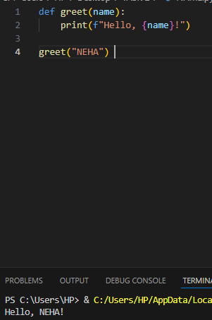

2.Create a function square(num) that returns the square of a given number.

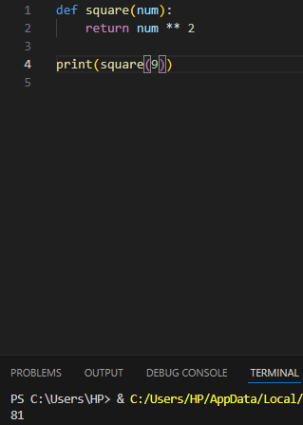

3.Write a function is_even(n) that returns True if a number is even, otherwise False.

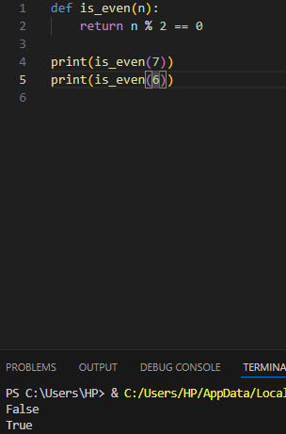

4.Define a function sum_numbers(a, b=10) that takes two numbers and returns their sum. If the second number is not provided, it should default to 10.

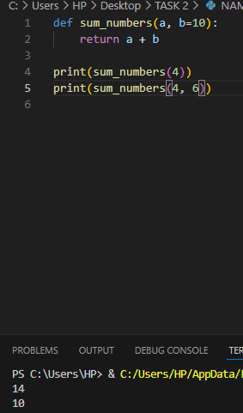

5.Write a recursive function factorial(n) to calculate the factorial of a number.

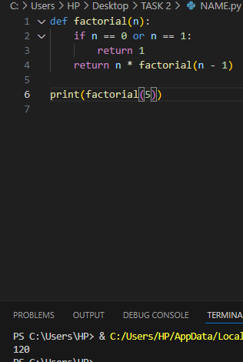

6.Use a lambda function with filter( ) to get all even numbers from a list:

[1, 2, 3, 4, 5, 6, 7, 8].

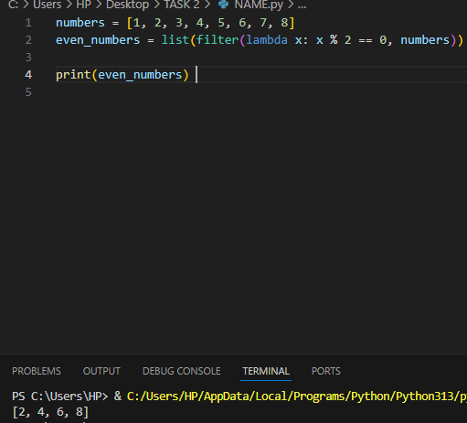

7. Write a while loop to print the first 5 multiples of 3.

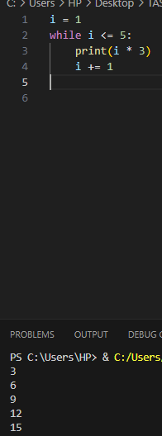

8. Create a loop that prints all numbers from 1 to 20 but skips multiples of 5.

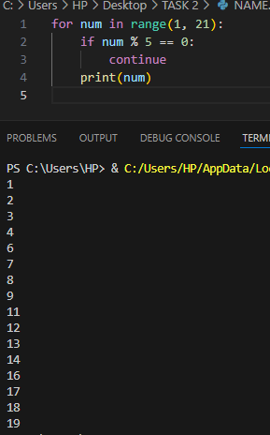

9. Write a loop that stops when it encounters the number 7 in this list:

[1, 2, 3, 4, 5, 6, 7, 8, 9].

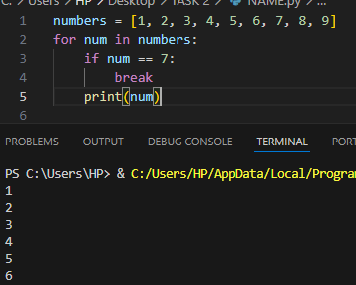

10. Write a program that checks if a year is a leap year. (Hint: A year is a leap year if it is divisible by 4 but not by 100, except when it is also divisible by 400.)

